  The Mustard Seed  “If you have faith as small as a mustard seed, nothing will be impossible for you.” Matthew 17:20-21 |  | 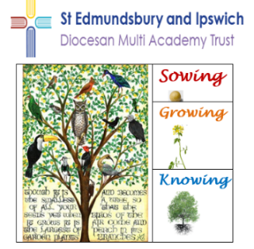  Our School Vision |   The Mustard Seed  “The Kingdom of Heaven is like a grain of mustard seed, when it is grown, it …becomes a tree, so that the birds of the air come and lodge in its branches. Matthew 13:31 – 32
Children | To ensure all pupils are proactively making positive progress in their learning and personal development by…  Understanding how our school vision applies to them and how they can contribute to it  Understanding and upholding our schools’ Christian values  Accessing a broad and diverse curriculum which supports opportunities to build knowledge and skills to thrive academically, socially and emotionally  Taking a responsible approach to their own learning behaviour, working hard and doing their best  Using Zones of Regulation to be aware of and maintain their wellbeing  Becoming independent learners who can challenge themselves, learn from mistakes and build resilience
Staff | To ensure provision for all pupils is consistently good or better by…  Supporting, developing and promoting the school vision for and with pupils  Promoting the schools’ Christian values and supporting pupils to do the same  Meeting the diverse needs of all pupils in their care  Providing opportunities for pupils to develop excellent knowledge and skills in maths, reading and writing and apply them to other subject areas across the curriculum  Planning to inspire pupils academically, creatively and technically and equip them for the modern world  Delivering a high quality RE curriculum
Stakeholders | To ensure that all Stakeholders contribute to securing positive outcomes for pupils by…  Parents and Guardians – Supporting their child to progress at school and encouraging their independence  Governors – Supporting and challenging the schools to continuously improve  Community – Developing and supporting links with the school to broaden pupils’ life experiences  Church – Maintaining links between the school and the church, leading collective worship and services and developing the Christian distinctiveness of the school  Our School is committed to growing and working together like The Mustard Seed

