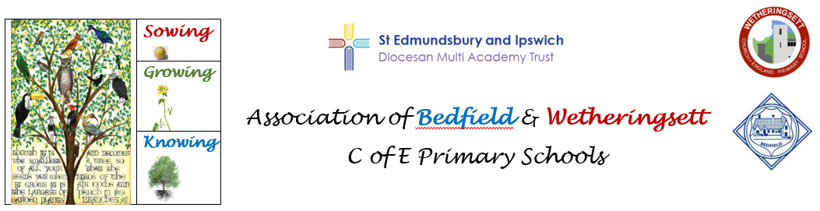

**PHSE (Personal, Health and Social Education)**

Supporting and extending personal and social development is very important to us at Wetheringsett C of E Primary School because it is part of equipping pupils with the foundations of the skill they will need to become effective citizens in the modern day world. Alongside academic knowledge and skills, self-knowledge and the ability to form successful relationships with others is essential. Hand in hand with our vision of growth, linked to The Parable of the Mustard Seed, comes our intention to develop our pupils’ inter-personal skills, knowledge of how to stay healthy and keep safe in a range of contexts, including on-line.

Our teaching schedule is derived from The PHSE Association, including RSE, Relationship and Sex Education which is taught as a block in the summer term in each year group at an age- appropriate level. Structured around our Three Big Ideas for the subject – Responsibility, Choice and Identity, in PHSE sessions children are guided through opportunities to develop their own self- awareness, recognition of feelings and how to respond to them, creating the initial steps of understanding others and gaining greater respect for diversity and the different choices people make about how to lead their lives.