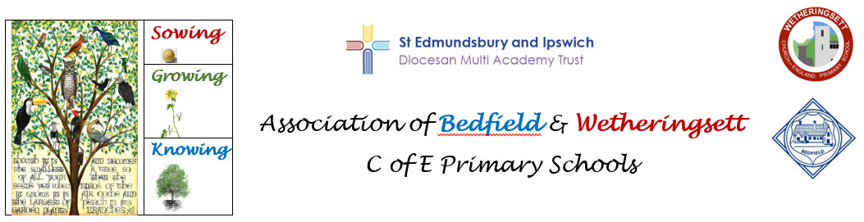

**Three Big Ideas**

**Coding**: Children understand logical thinking and use it to create algorithms and programs

**Communication**: Children know how to use information and communication technology to express and present ideas effectively

**E-Safety**: Children know how to use technology responsibly and know how to stay safe online.

**Overview of Computing Planning (Cycle 1)**

|  |  |  |  |  |  |  |
| --- | --- | --- | --- | --- | --- | --- |
|  | **Autumn 1**  195,944 Fall Leaf White Background Stock Photos - Free & Royalty-Free Stock  Photos from Dreamstime | **Autumn 2**  195,944 Fall Leaf White Background Stock Photos - Free & Royalty-Free Stock  Photos from Dreamstime | **Spring 1**  Crocus white background Stock Photos - Page 1 : Masterfile | **Spring 2**  Crocus white background Stock Photos - Page 1 : Masterfile | **Summer 1**30,861 Beautiful Sunflower White Background Stock Photos - Free &  Royalty-Free Stock Photos from Dreamstime | **Summer 2**30,861 Beautiful Sunflower White Background Stock Photos - Free &  Royalty-Free Stock Photos from Dreamstime |
|  | **Computer Systems & Networks** | **Creating Media** | **Programming** | **Data & Information** | **Creating Media** | **Programming** |
| EYFS | Use a range of small tools, including scissors, paintbrushes and cutlery. | To explore a variety of materials, tools and techniques, experimenting with colour, design, texture, form and function. | Work and play cooperatively and take turns with others. | Explore and represent patterns within numbers up to 10, including evens and odds, double facts and how quantities can be distributed equally. | Demonstrate understanding of what has been read to them by retelling stories and narratives using their own words and recently introduced vocabulary. | Be confident to try new activities and show independence, resilience and perseverance in the face of challenge. |
| Year 1/2 | **Technology around us**  To become more familiar with the different components of a computer by developing keyboard and mouse skills, and also start to consider how to use technology responsibly. | **Digital painting**  To create paintings, using digital painting software, while getting inspiration from a range of other artists. | **Moving a robot**  To explore using individual commands, both with other learners and as part of a computer program. They will identify what each floor robot command does and use that knowledge to start predicting the outcome of programs. | **Grouping data**  To assign data (images) with different labels in order to demonstrate how computers are able to group and present data. This will include logging onto the computer, loading and saving documents. | **Digital writing**  To develop understanding of the various aspects of using a computer to create and change text and to consider the differences between using a computer and writing on paper to create text. | **Robot algorithms**  To develops understanding of instructions in sequences and the use of logical reasoning to predict outcomes; to design algorithms and then test those algorithms as programs and debug them. |
| Year 3/4 | **Connecting computers** Identifying that digital devices have inputs, processes, and outputs, and how devices can be connected to make networks | **Stop-frame animation**  Capturing and editing digital still images to produce a stop-frame animation that tells a story. | **Sequencing sounds**  Creating sequences in a block-based programming language to make music. | **Branching databases**  Building and using branching databases to group objects using yes/no questions. | **Desktop publishing** Creating documents by modifying text, images, and page layouts for a specified purpose. | **Repetition in shapes**  Using a text-based programming language to explore count-controlled loops when drawing shapes |
| Year 5/6 | **Systems and searching:** Recognising IT systems in the world and how some can enable searching on the internet. | **Video production:** Planning, capturing, and editing video to produce a short film. | **Selection in physical computing:**  Exploring conditions and selection using a programmable microcontroller | **Flat-file databases:**  Using a database to order data and create charts to answer questions. | **Introduction to vector graphics:** Creating images in a drawing program by using layers and groups of objects. | **Variables in games:** Exploring variables when designing and coding a game. |

**Overview of Computing Planning (Cycle 2)**

|  |  |  |  |  |  |  |
| --- | --- | --- | --- | --- | --- | --- |
|  | **Autumn 1**  195,944 Fall Leaf White Background Stock Photos - Free & Royalty-Free Stock  Photos from Dreamstime | **Autumn 2**  195,944 Fall Leaf White Background Stock Photos - Free & Royalty-Free Stock  Photos from Dreamstime | **Spring 1**  Crocus white background Stock Photos - Page 1 : Masterfile | **Spring 2**  Crocus white background Stock Photos - Page 1 : Masterfile | **Summer 1**30,861 Beautiful Sunflower White Background Stock Photos - Free &  Royalty-Free Stock Photos from Dreamstime | **Summer 2**30,861 Beautiful Sunflower White Background Stock Photos - Free &  Royalty-Free Stock Photos from Dreamstime |
|  | **Computer Systems & Networks** | **Creating Media** | **Programming** | **Data & Information** | **Creating Media** | **Programming** |
| EYFS | Use a range of small tools, including scissors, paintbrushes and cutlery. | Create collaboratively, sharing ideas, resources and skills. | Work and play cooperatively and take turns with others. | Explore and represent patterns within numbers up to 10, including evens and odds, double facts and how quantities can be distributed equally. | Explore and engage in music making, performing solo and in groups. | Be confident to try new activities and show independence, resilience and perseverance in the face of challenge. |
| Year 1/2 | **I.T. around us**  Toexplore how IT benefits society in places such as the home, shops, libraries, and hospitals. Whilst discussing the responsible use of technology, and how to make smart choices when using it. | **Digital photography**   To recognise that different devices can be used to capture photographs and gain experience capturing, editing, and improving photos. | **Programming animations**  To explore the way a project looks by investigating sprites and backgrounds. To develop understanding of how to use programming blocks to use, modify, and create programs and develop the early stages of program design through the introduction of algorithms. | **Pictograms**  To understand what data means and how this can be collected in the form of a tally chart; to learn the term ‘attribute’ and use this to help organise data; to progress onto presenting data in the form of pictograms and finally block diagrams. | **Digital music**  To make patterns and use those patterns to make music with both percussion instruments and digital tools; to create different rhythms and tunes, using the movement of animals for inspiration; to compare creating music digitally and non-digitally. | **Programming quizzes**  To use and modify designs to create their quiz questions in ScratchJr and realise these designs in ScratchJr using blocks of code. |
| Year 3/4 | **The internet** Recognising the internet as a network of networks including the WWW, and why we should evaluate online content. | **Audio production** Capturing and editing audio to produce a podcast, ensuring that copyright is considered | **Events and actions in programs**  Writing algorithms and programs that use a range of events to trigger sequences of actions. | **Data logging** Recognising how and why data is collected over time, before using data loggers to carry out an investigation. | **Photo editing** Manipulating digital images, and reflecting on the impact of changes and whether the required purpose is fulfilled. | **Repetition in games:**  Using a block-based programming language to explore count-controlled and infinite loops when creating a game. |
| Year 5/6 | **Communication and collaboration:** Exploring how data is transferred by working collaboratively online. | **Webpage creation:** Designing and creating webpages; considering copyright issues, aesthetics and navigation. | **Selection in quizzes** Exploring selection in programming to design and code an interactive quiz. | **Introduction to spreadsheets:** Answering questions by using spreadsheets to organise and calculate data | **3D modelling:** Planning, developing, and evaluating 3D computer models of physical objects. | **Sensing movement** Designing and coding a project that captures inputs from a physical device. |