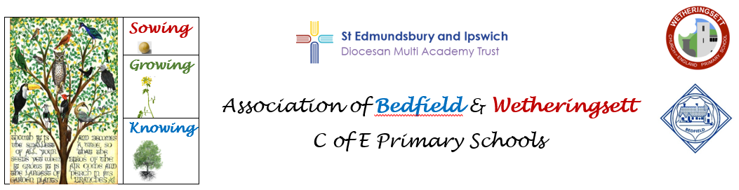

**Overview of PE Planning**

**Three Big Ideas:**

**Activity:** Children understand how controlled physical activity contributes to improvements in mental health and physical fitness

**Collaboration:** Children learn how to be a team player by performing skillfully in role and showing empathy and fairness

**Challenge:** Children have the confidence to take part in indoor and outdoor challenges and competitive sports, with increasing skill

**PE plans are taken from Complete PE** [**https://www.portal.completepe.com/portal**](https://www.portal.completepe.com/portal)

|  |  |  |  |  |  |  |
| --- | --- | --- | --- | --- | --- | --- |
| **(Cycle 1)**  **2022-23** | **Autumn 1**  195,944 Fall Leaf White Background Stock Photos - Free & Royalty-Free Stock  Photos from Dreamstime | **Autumn 2**  195,944 Fall Leaf White Background Stock Photos - Free & Royalty-Free Stock  Photos from Dreamstime | **Spring 1**  Crocus white background Stock Photos - Page 1 : Masterfile | **Spring 2**  Crocus white background Stock Photos - Page 1 : Masterfile | **Summer 1**30,861 Beautiful Sunflower White Background Stock Photos - Free &  Royalty-Free Stock Photos from Dreamstime | **Summer 2**30,861 Beautiful Sunflower White Background Stock Photos - Free &  Royalty-Free Stock Photos from Dreamstime |
| **EYFS** | Walking 1 | Ourselves | Hands 2 | Nursery rhymes | Feet 1 | Games for understanding |
| **KS1** | **Coach -**  tennis  **School -**  Forest schools  Team building  (year 1 unit) | **Coach -** Tag rugby  **School -**  Forest schools  Gym/Dance (explorers) | **Coach -** Gymnastics Football  **School -**  Forest school  Gym/dance | **Coach -** Basketball  **School -** Forest schools Orienteering | **Coach -** Athletics  **School -**  Forest school  Swimming | **Coach -** Hockey  **School -** Forest school  Rounders |
| **KS2** | **Coach -**  tennis  **School -**  Forest schools  Team building | **Coach -** Tag rugby  **School -**  Forest schools  Gym/Dance | **Coach -** Gymnastics Football  **School -**  Forest school  Gym/dance | **Coach -** Basketball  **School -** Forest schools Orienteering | **Coach -** Athletics  **School -**  Forest school  Swimming | **Coach -** Hockey  **School -** Forest school  Rounders |
|  |  |  |  |  |  |  |

***Developing Experts provide an end of unit assessment for each topic.***

|  |  |  |  |  |  |  |
| --- | --- | --- | --- | --- | --- | --- |
| **(Cycle 2)**  **2023-24** | **Autumn 1**  195,944 Fall Leaf White Background Stock Photos - Free & Royalty-Free Stock  Photos from Dreamstime | **Autumn 2**  195,944 Fall Leaf White Background Stock Photos - Free & Royalty-Free Stock  Photos from Dreamstime | **Spring 1**  Crocus white background Stock Photos - Page 1 : Masterfile | **Spring 2**  Crocus white background Stock Photos - Page 1 : Masterfile | **Summer 1**30,861 Beautiful Sunflower White Background Stock Photos - Free &  Royalty-Free Stock Photos from Dreamstime | **Summer 2**30,861 Beautiful Sunflower White Background Stock Photos - Free &  Royalty-Free Stock Photos from Dreamstime |
| **EYFS** | Dinosaurs | Hands 1 | High, low, over, under | Moving | Jumping 1 | Games for understanding |
| **KS1** | **Coach -** Tennis  **School -**  Forest schools  Team building  (year 2 unit) | **Coach -** Tag rugby  **School -**  Forest schools  Gym/Dance (water) | **Coach -** Gymnastics Football  **School -**  Forest school  Gym/dance | **Coach -** Basketball  **School -** Forest schools Orienteering | **Coach -** Athletics  **School -**  Forest school  Swimming | **Coach -** Hockey  **School -** Forest school  Cricket |
| **KS2** | **Coach -** Tennis  **School -**  Forest schools  Team building | **Coach -** Tag rugby  **School -**  Forest schools  Gym/Dance | **Coach -** Gymnastics Football  **School -**  Forest school  Gym/dance | **Coach -** Basketball  **School -** Forest schools Orienteering | **Coach -** Athletics  **School -**  Forest school  Swimming | **Coach -** Hockey  **School -** Forest school  Cricket |
|  |  |  |  |  |  |  |

***Developing Experts provide an end of unit assessment for each topic.***

**NB** Where EYFS are taught with KS1, Use EYFS topic as introductory activities to each session.