# **A picture containing text, clock, sign Description automatically generatedFilm Reel Images – Browse 320,932 Stock Photos, Vectors, and Video | Adobe StockDiagram Description automatically generated with low confidenceMaths at the Movies**

# **Wetheringsett C of E Primary School**

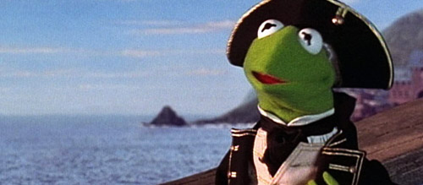**Sycamore (Year 3/4) and Chestnut Class (Year 5/6) watched…**

**Muppet Treasure Island**

In keeping with the theme of the movie, children in Sycamore learnt how to read coordinates on a map and applied this to solve a mystery message in a bottle.

The children then created pirate treasure maps. Using their maps, they described a journey using coordinates, visiting until they reached

'x marks the spot.’

Chestnut Class also learnt how to translate shapes to different quadrants on a grid.

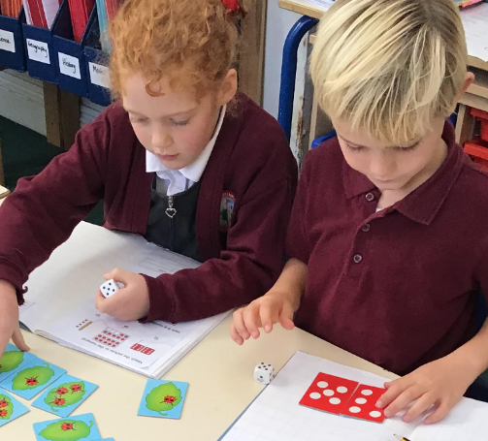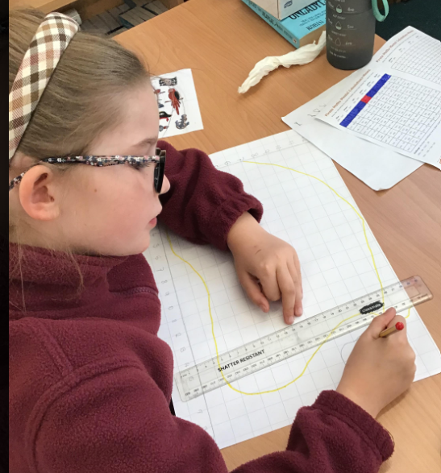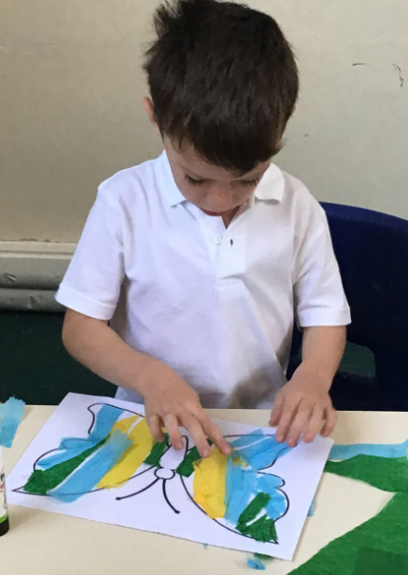

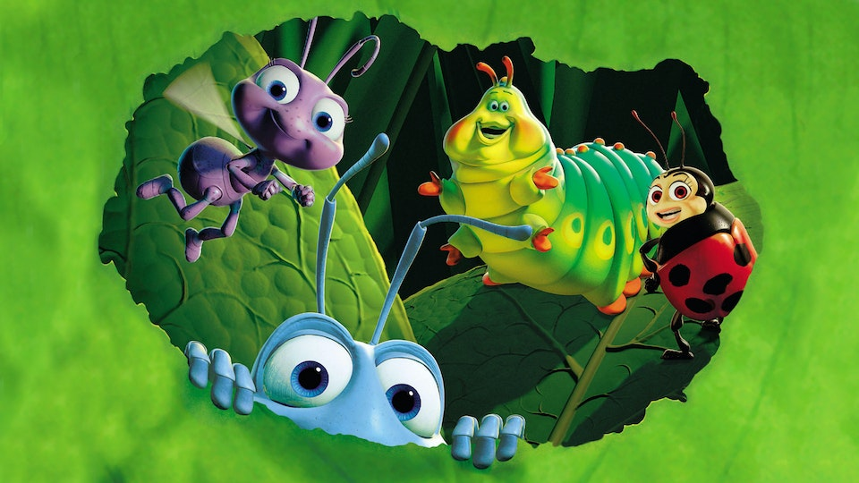Children in Lyme Class (Reception/Year1/2) watched,

A Bug’s Life

and learnt all about symmetry with Butterfly Wings. They counted in 2s legs using insect legs and practiced number bonds with ant armies, bugs grouping and counting number bonds to 20.